**A**

**PROJECT REPORT**

**ON**

**“ROSE PETALS BEAUTY SALON”**

**FOR**

**“Lexicon Networks India Pvt Ltd”**

**IN PARTIAL FULLFILLMENT OF**

**MASTER OF COMPUTER APPLICATION**

**BY**

**Mr. Lagad Shubham Sambhaji**

**MCA- II SEM – IV**

**(2022-2023)**

**SUBMITTED TO**

**SAVITRIBAI PHULE PUNE UNIVERSITY**

**SINHGAD INSTITUTE OF MANAGEMENT**

**PUNE-411041**

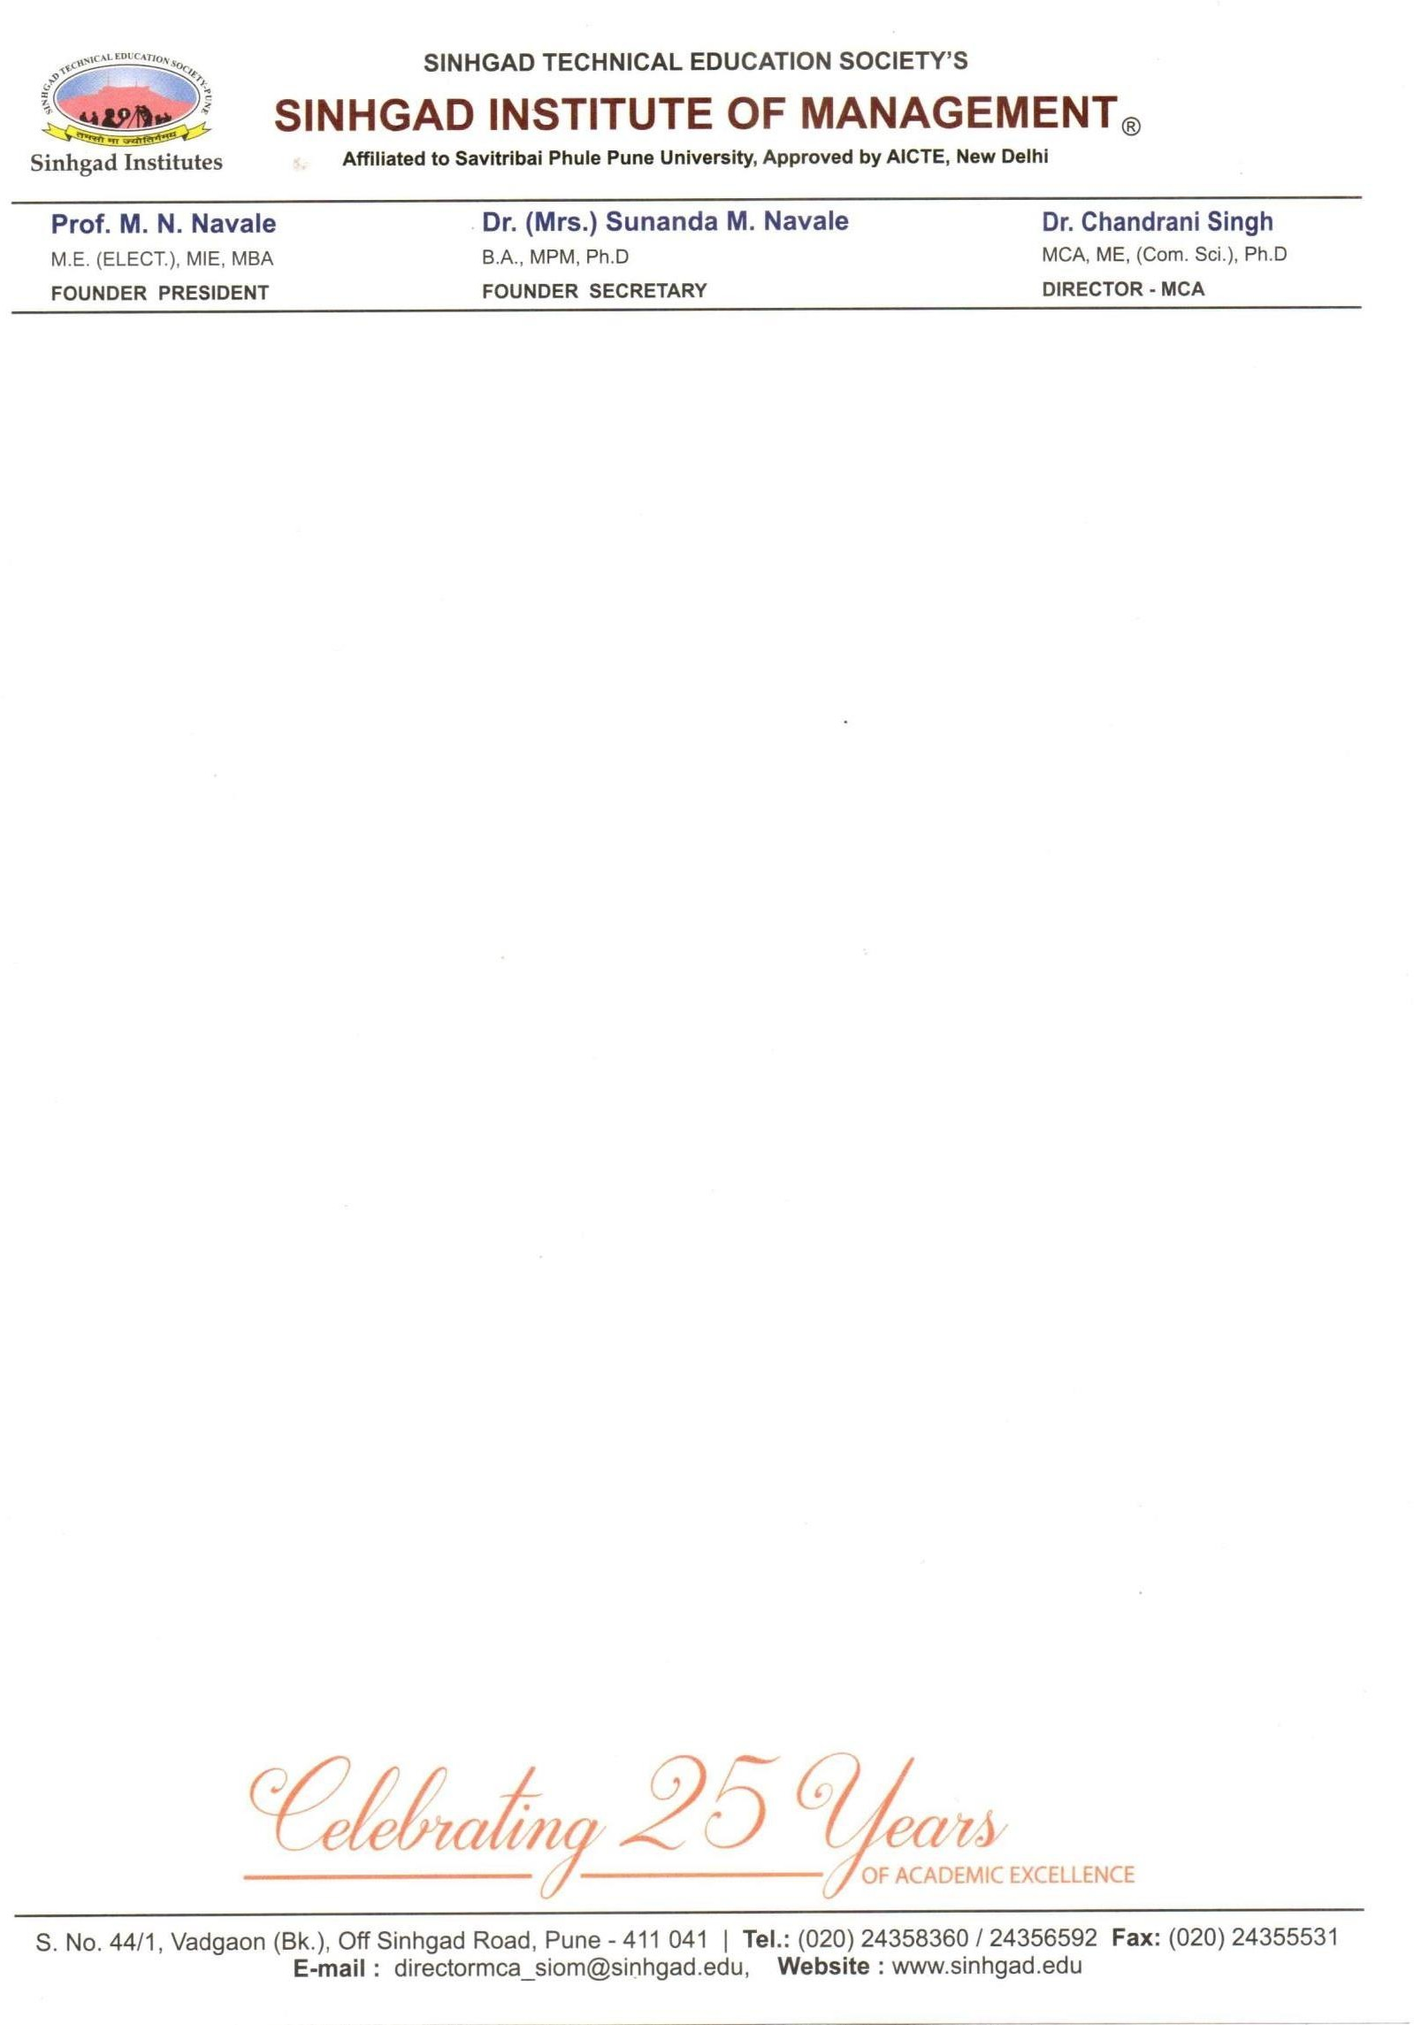

# Date: / /

**CERTIFICATE**

This is to certify that Mr. Lagad Shubham Sambhaji, has successfully /Partially

completely his internship project work entitled “**Rose Petals Beauty Salon**” in

partial fulfilment of MCA – II SEM –IV Internship Project for the year 2022-2023. He

has worked under our guidance and direction.

# Ms. Kumudini Manwar Dr. Chandrani Singh

**Project Guide Director, SIOM-MCA**

**Examiner 1 Examiner 2**

**Date: / /**

**Place**

Lexicon Networks India Pvt Ltd.

*“Saas Integration Specialist”*

Abhishek Pandey

Lexicon Networks India Pvt Ltd.

Pune 411062

**April 21, 2023**

**Subject:** Offer Letter for the position of “Trainee Software Engineer” at Lexicon Networks India.

# Dear Shubham Lagad,

You will be working with us as a “Trainee Software Engineer” for a period of 3 months. In this period, you will receive training and assignments on various projects within Lexicon Networks India.

At the end of this training period, Lexicon Networks India may offer you employment opportunities based on your performance during the training program. For the training purpose we will provide a project or assignment different technologies. So, we are assigning to you the project “**Rose Petals Beauty Salon**”.

Please follow the instructions and do complete the given project in respective time period.

# Terms and Conditions

1. Your confirmation with the Lexicon Networks India will be dependent on your performance during the 3 months training period.
2. You will not be eligible for any stipend till the completion of your 3 months.
3. As a Lexicon Networks India trainee/intern you are expected to abide by all the policies as per the Lexicon Networks India handbook.

We are planning for your official start date as **25th Apr 2023**. We look forward to having you on our team!

Yours Sincerely,

# Abhishek Pandey



Manager - HR

**Regd. Office:** 2nd Floor, Sanket Apartments, 3/9 Yashshree Colony, Cummins College Road, Karvenagar, Pune 411062 Ph: 9834960800, 7620878611 **Corporate office**: One Tiffany Pointe, Suite 4G Bloomingdale, IL 60108 **www.lexiconnetworks.com**

**DECLARATION**

We certify that the work contained in this report is original and has been done by us under the guidance of my supervisor(s).

* The work has not been submitted to any other Institute for any degree or diploma.
* We have followed the guidelines provided by the Institute in preparing the report.
* We have conformed to the norms and guidelines given in the Ethical Code of Conduct of the Institute.
* Whenever we have used materials (data, theoretical analysis, figures, and text) from other sources, we have given due credit to them by citing them in the text of the report and giving their details in the references.

**Name and Signature of Project Team Members:**

|  |  |  |  |
| --- | --- | --- | --- |
| **Sr. No.** | **Seat No.** | **Name of students** | **Signature of students** |
| **1** | **445** | **Lagad Shubham Sambhaji** |  |

**ACKNOWLEDGEMENT**

We have immense pleasure in expressing our sincerest and deepest sense of gratitude towards our **Guide** **Ms. Kumudini Manwar** for the assistance, valuable guidance and co-operation in carrying out this Project successfully. We have developed this project with the help of Faculty members of our institute and we are extremely grateful to all of them. We also take this opportunity to thank **Director** **Dr. Chandrani Singh**, for providing the required facilities in completing this project. We are greatly thankful to our parents, friends and faculty members for their motivation, guidance and help whenever needed.

**Thank You,**

**Lagad Shubham Sambhaji**

**Index**

|  |  |  |  |
| --- | --- | --- | --- |
| **Chapter No** |  | **Details** | **Page No.** |
| **1** |  | **Introduction** | **1** |
|  | 1.1 | Company Profile | 1 |
|  | 1.2 | Abstract | 1 |
|  | 1.3 | Existing System and Need for System | 2 |
|  | 1.4 | Scope of System | 3 |
|  | 1.5 | Operating Environment - Hardware and Software | 4 |
|  | 1.6 | Brief Description of Technology Used  1.6.1 Operating systems used (Windows or Unix)  1.6.2 RDBMS/No SQL used to build database (MySQL/ oracle, Teradata,  etc.) | 4 |
| **2** |  | **Proposed System** | **6** |
|  | 2.1 | Study of Similar Systems (If required research paper can be included) | 6 |
|  | 2.2 | Feasibility Study | 7 |
|  | 2.3 | Objectives of Proposed System | 8 |
|  | 2.4 | Users of System | 8 |
| **3** |  | **Analysis and Design** | **9** |
|  | 3.1 | System Requirements (Functional and Non-Functional requirements) | 9 |
|  | 3.2 | Entity Relationship Diagram (ERD) | 10 |
|  | 3.3 | Table Structure | 10 |
|  | 3.4 | Use Case Diagrams | 13 |
|  | 3.5 | Class Diagram | 18 |
|  | 3.6 | Activity Diagram | 19 |
|  | 3.7 | Deployment Diagram | 20 |
|  | 3.8 | Module Hierarchy Diagram | 20 |
|  | 3.9 | Sample Input and Output Screens (Screens must have valid data. All reports must have at-least 5 valid records.) | 23 |
| **4** |  | **Coding** | **37** |
|  | 4.1 | Algorithms |  |
|  | 4.2 | Code snippets |  |
| **5** |  | **Testing** | **76** |
|  | 5.1 | Test Strategy | 76 |
|  | 5.2 | Unit Test Plan | 76 |
|  | 5.3 | Acceptance Test Plan | 77 |
|  | 5.4 | Test Case / Test Script | 78 |
|  | 5.5 | Defect report / Test Log | 78 |
| 6 |  | **Limitations of Proposed System** | **79** |
| **7** |  | **Proposed Enhancements** | **79** |
| **8** |  | **Conclusion** | **79** |
| **9** |  | **Bibliography** | **80** |
| **10** |  | **User Manual** (All screens with proper description/purpose Details about validations related to data to be entered.) | **81** |